**Experiment 2:-**

Aim:-Design a LED chaser.

Apparatus:- Arduino board,Bread board,Wires,LED’s,Resistor etc.

Circuit diagram:-

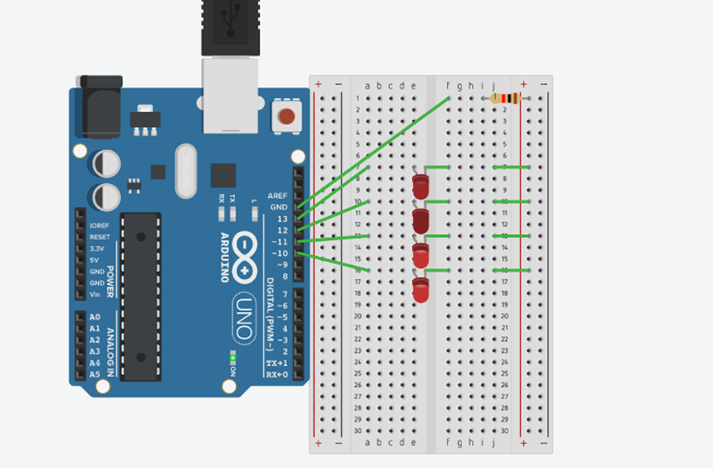

**Theory:-**

Concept used:-

The concept used in this experiment are as follows:-

* The arduino board can supply a power of 5V as digital output signals through 14pins present in it as digital input or output pins.
* In the breadboard the two rows present at the top and bottom each are connected with each other in series and columns present in between are connected in a set of 5 each.The connection pattern is shown below:-

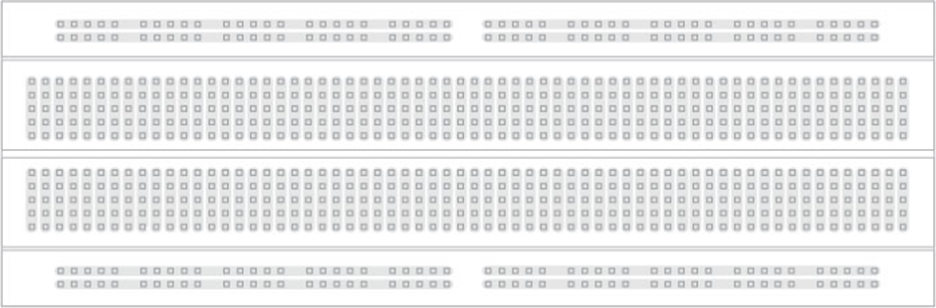

* The GND pin of arduino board acts as a ground.
* Arduino board provides the digital signals with the help of which LED’s will glow accordingly.
* In series circuit voltage gets divided and in parallel circuit current gets divided.
* Ohm’s law:-Ohm’s law states that the current through a conductor is directly proportional to the voltage across the two points provided that the temperature remains constant.

V=IR

* Kirchoff’s current law:- It states that the total current flowing through a junction is equals to current flowing of the junction.

**Learning and observations:-**

Learning:-

* After doing this experiment I have learned how to make the parallel connections using an arduino board and bread board.
* I have learned how we can make the various LED’s glow simultaneously with the help of doing various patterns by using 4-5 bulbs or more than this using in parallel connections.
* I have learned that how arduino works and with the help of it we can make our LED’s glow.
* I have gained a practical experience of electronic circuits and how we can work with these circuits.

**Objectives:-**

While doing this experiment I observed that first two LED’s glow and then the first led goes off and the third one glows and a chain like this is formed and this pattern we made for the arduino board to pass signals.

**Learning Outcomes:-**

* Through this experiment I have learned how to make the parallel connections and how we can connect the different hardwares with arduino board.
* After doing this experiment I have gained a skill of making different kinds of patterns of light using LED’s and arduino board.

**Problems and troubleshooting:-**

* The ends of the wire were not getting inserted properly in the holes of the breadboard so I had to make the ends of the wire straight first using a sand paper.
* The arduino board was not working properly .The cable connecting the arduino board was loose at one end so I had to replace the cable with the new one.
* The LED’s were not working properly so I had to replace them with the new ones.
* The required pattern were not getting created as there was some error in the code so I had to change the code as per requirement.

**Precautions:-**

* The connections should be tight and wires should be connected at their appropriate position so that circuit doesn’t get short.
* We should keep in mind that circuit should be closed.
* The two pins of the LED should be connected at their appropriate point that is the positive point should be connected with p pin and the negative point should be connected with negative pin.